

**MINI PROJECT BCI1093 DATA STRUCTURE & ALGORITHM**

**TITLE: CAR WASH MANAGEMENT SYSTEM**

**LECTURER’S NAME: MR. WAN MUHAMMAD SYAHRIR BIN WAH HUSSIN**

|  |  |  |
| --- | --- | --- |
| **Matric ID** | **Name** | **Section** |
| CB18047 | SYAHIER AQIF BIN SABRI | 03A |
| CB18050 | MUHAMMAD FAIZ BIN FAUZI | 03A |
| CB18041 | NURSHAHIR IZMIN BIN SALLEH | 03A |

Table of Contents

**1.0 INTRODUCTION** 3

**1.1 CASE STUDY** 4

Case Study 1 4

Case Study 2 5

**1.2 PROJECT DESCRIPTION** 6

**1.3 Input Output** 7

Figure 3:Main interface of the system 7

Figure 4:Main interface for admin 7

Figure 5:Main interface for add car 8

Figure 6:Main interface for add car(package) 8

Figure 7:Main Interface View Car 9

Figure 8:Main Interface Remove Car 9

Figure 9:Main interface Add Employee 9

Figure 10:Main Interface View Employee 10

Figure 11:Main Interface Search Employee 10

Figure 12:Main Interface Analysis 11

**1.4 APPENDIX** 12

# **1.0 INTRODUCTION**

In this modern age,everything is evolving.Same goes to car wash.Now,car wash can be done in a system.With system,there are a lot of benefits to the user than the old way of car wash.User don’t need to spend their time and energy to find the most preferred car wash shop that can fully fill their satisfaction because the details of the car wash shop is unclear compared to a system...

By using the car wash management system,all the details about the car wash has been shown to the user and time and energy of the user will be saved.If the customer or the user still demand for more details,they can contact the owner of the system in a various ways provided by the system as example by phone call.

With this system,the user or the customer of the store can know the progress of their vehicle and the price of the package provided.User can choose the package easily by a single click compared to the old way which is the customer of the store need to ask the workers or the store owner about package and price to make sure they was satisfied and in range of their budget.

Last but not least,this system is created for those who are busy in their daily routine and life because time spend to use this system is very short but very productive and can reduce many other difficulties compared to the old way car wash withoust a system.

# **1.1 CASE STUDY**

## Case Study 1

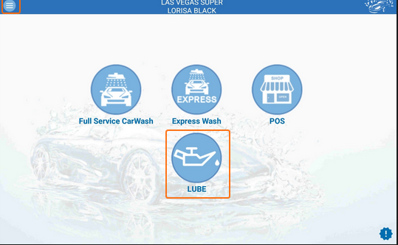

Figure 1:SciWash system

**Sciwash Cloud** system car wash software is a cloud software consisting of three modules. They include the **CarWashExpress** system itself, used for provision of car washing services to car owners. Lube module is used for car maintenance: oil change or spare parts search by VIN code. The third essential element is the POS module for conduct of financial transactions, implementation of loyalty programs, establishment of client data bases with vehicles information etc.

The software ensures the following advantages for its users simplicity and **comprehensiveness,guaranteed security,full control even for a number of car washes,multi-tasking,simple integration with payment systems** and **free trial**.

**Car Wash Software Retrieved December 7,2019,from https://sciwash.com/car-wash/**

## Case Study 2

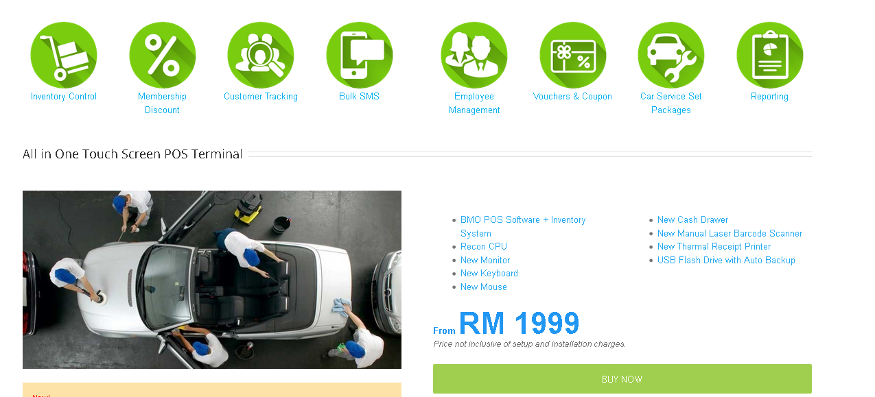

Figure 2:Car Wash POS System

This **POS Market POS System Car Wash** modules work perfectly for **car wash business**, **premium car detailing business** and so much more. The features in our **Car Wash POS System** can systematically plan the **schedule** with **service reminders** and **customer record tracking.**

**Profitability** can be enhanced easily with the **POS inventory control** feature that helps **record tangible products** that can **upsell** to the **car wash customers**. Besides client management, we can also make sure our shop is on top of its game with the **POS Employee Management** system and a great **commissions module** to encourage our staff to work harder and serve the customers better.

**(2019,July 24). POS Market POS System.Retrieved December 7,2019,from** [**https://www.posmarket.com.my/pos-system-for-car-wash/**](https://www.posmarket.com.my/pos-system-for-car-wash/)

# **1.2 PROJECT DESCRIPTION**

|  |  |
| --- | --- |
| **Title** | **Description** |
| Car Wash Management System | -User login(admin/staff)  Car Wash Queue management  -Add car into Queue  -Enter car details  -Select package  -Enter customer details  -View Car Queue  -Display plate number,model,package.  -Display customer name,customer phone number.  -Remove car from Queue  Staff Management**(admin only)**  -Add Employee  -Enter staff details  -Undo Register Employee  - Remove recently register employee  -View Employee  -Display staff details  -Search Employee  -Search staff by staff ID  -Display staff details(if found)  Analytic**(admin only)**  -View Analysis  -Display time generated  -Display number of car,MPV,SUV  -Display amount from Car,MPV,SUV  -Display total amount  -Log out |

# **1.3 Input Output**

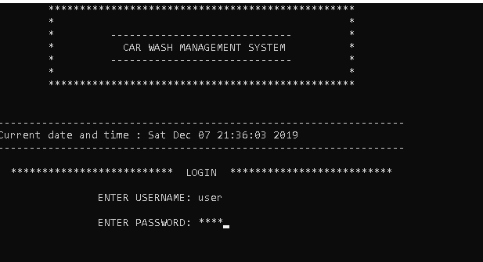

### Figure 3:Main interface of the system

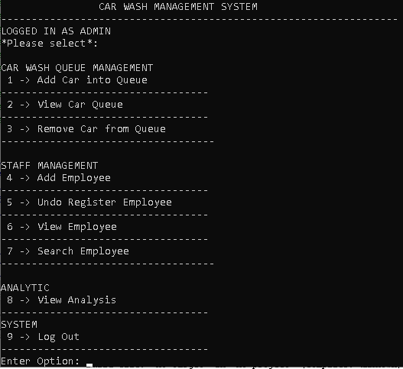

### Figure 4:Main interface for admin

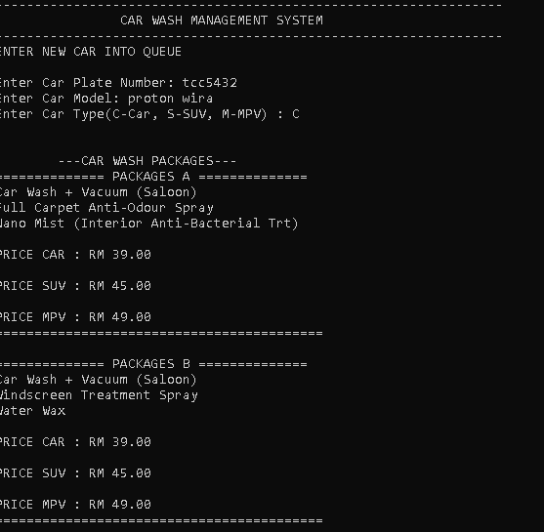

### Figure 5:Main Interface for Add Car

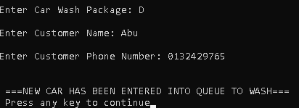

### Figure 6:Main Interface for Add Car(package)

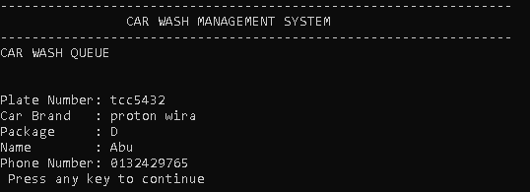

### Figure 7:Main Interface View Car

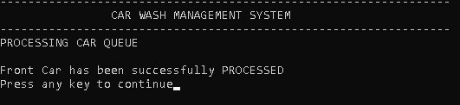

### Figure 8:Main Interface Remove Car

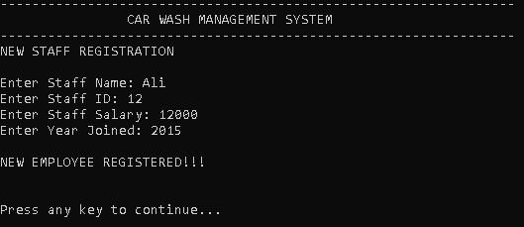

### Figure 9:Main interface Add Employee

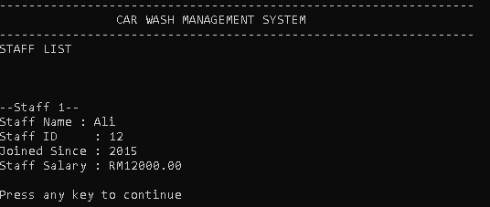

### Figure 10:Main Interface View Employee

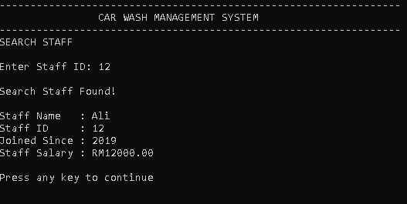

### Figure 11:Main Interface Search Employee

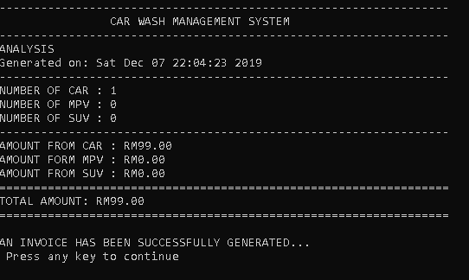

### Figure 12:Main Interface Analysis

## **1.4 APPENDIX**

#include <stdio.h>

#include <string.h>

#include <stdlib.h>

#include <conio.h>

#include <time.h>

#include <ctype.h>

#define TRUE 1

#define FALSE 0

#define MAXSTACK 15

//Staff Stack

int top=-1;

char stackStaffName[MAXSTACK][20];

int stackStaffID[MAXSTACK];

float stackStaffSalary[MAXSTACK];

int stackStaffYear[MAXSTACK];

//Function

int login();

void adminMenu();

void employeeMenu();

//Car Function

void addCar();

void listCar();

void deleteCar();

//Employee Management Function

void pushStaff();

void popStaff();

void viewStaff();

void findStaff();

void bubbleSort();

void exchange(int,int);

//Analytic

void viewAnalysis();

//CAR STRUCTURE

typedef struct cust

{

char custName[20];

char phoneNumber[20];

};

typedef struct car

{

char plateNum[10];

char model[20];

int type;

char package;

double price;

struct cust cust_detail;

struct car *link;

}NODE;

NODE *front,*rear,*delNode;

//Global Variable

float totalCar = 0;

int carCount = 0;

float totalMPV = 0;

int MPVcount = 0;

float totalSUV = 0;

int SUVcount = 0;

float totalProfit;

int main(){

time_t t;

time(&t);

printf("\t*************************************************\n");

printf("\t* *\n");

printf("\t* ----------------------------- *\n");

printf("\t* CAR WASH MANAGEMENT SYSTEM *\n");

printf("\t* ----------------------------- *\n");

printf("\t* *\n");

printf("\t*************************************************\n\n\n");

for(int i=0;i<65;i++)

printf("-");

printf("\nCurrent date and time : %s",ctime(&t));

for(int i=0;i<65;i++)

printf("-");

int access = login();

if(access == 1)

adminMenu();

else

employeeMenu();

}

int login(){

int access = 0;

int a=0,i=0;

char uname[10],c=' ';

char pword[10],code[10];

char admin[10] = "admin";

char adminPass[10] = "password";

char emp[10] = "user";

char empPass[10] = "pass";

do

{

printf("\n\n ************************** LOGIN ************************** ");

printf(" \n\n ENTER USERNAME: ");

scanf("%s", &uname);

printf(" \n ENTER PASSWORD: ");

while(i<10)

{

pword[i]=getch();

c=pword[i];

if(c==13) break;

else printf("*");

i++;

}

pword[i]='\0';

i=0;

if(strcmp(uname,admin)==0 && strcmp(pword,adminPass)==0)

{

printf("\n\n\n LOGIN IS SUCCESSFUL!");

printf("\n LOGGED IN AS ADMIN");

access = 1;

return access;

}

else if(strcmp(uname,emp)==0 && strcmp(pword,empPass)==0)

{

printf("\n\n\n LOGIN IS SUCCESSFUL!");

printf("\n LOGGED IN AS STAFF");

access = 2;

return access;

}

else

{

printf("\n\n\n SORRY !!!! LOGIN IS UNSUCESSFUL");

a++;

getch();

}

}

while(a<=2);

if (a>2)

{

printf("\nSorry you have entered the wrong username and password for four times!!!");

getch();

}

system("cls");

}

//MENU

void adminMenu(){

int choice;

while (1){

system("cls");

for(int i=0;i<65;i++)

printf("-");

printf("\n\t\tCAR WASH MANAGEMENT SYSTEM\n");

for(int i=0;i<65;i++)

printf("-");

printf("\nLOGGED IN AS ADMIN");

printf("\n*Please select*:");

printf("\n\n");

printf("CAR WASH QUEUE MANAGEMENT");

printf(" \n 1 -> Add Car into Queue");

printf("\n----------------------------------");

printf(" \n 2 -> View Car Queue");

printf("\n----------------------------------");

printf(" \n 3 -> Remove Car from Queue");

printf("\n-----------------------------------");

printf("\n\nSTAFF MANAGEMENT");

printf(" \n 4 -> Add Employee");

printf("\n----------------------------------");

printf(" \n 5 -> Undo Register Employee");

printf("\n----------------------------------");

printf(" \n 6 -> View Employee");

printf("\n----------------------------------");

printf(" \n 7 -> Search Employee");

printf("\n-----------------------------------");

printf("\n\nANALYTIC");

printf(" \n 8 -> View Analysis");

printf("\n----------------------------------");

printf("\nSYSTEM");

printf(" \n 9 -> Log Out");

printf("\n----------------------------------");

printf("\nEnter Option: ");

choice=getche();

choice=toupper(choice);

switch(choice)

{

case '1':

addCar();break;

case '2':

listCar();break;

case '3':

deleteCar();break;

case '4':

enterStaff();break;

case '5':

popStaff();break;

case '6':

viewStaff();break;

case '7':

findStaff();break;

case '8':

viewAnalysis();break;

case '9':

system("cls");

time_t t;

time(&t);

printf("\n\n\t *****SUCCESSFULLY LOGGED OUT FROM THE SYSTEM*****\n");

for(int i=0;i<65;i++)

printf("-");

printf("\n\t\t %s \n",ctime(&t));

for(int i=0;i<65;i++)

printf("-");

exit(0);

break;

default:

system("cls");

printf("Incorrect Input");

printf("\n Press any key to continue");

getch();

}

}

}

void employeeMenu(){

char choice;

while (1){

system("cls");

for(int i=0;i<65;i++)

printf("-");

printf("\n\t\tCAR WASH MANAGEMENT SYSTEM\n");

for(int i=0;i<65;i++)

printf("-");

printf("\nLOGGED IN AS STAFF");

printf("\n*Please select*:");

printf("\n\n");

printf(" \n 1 -> Add Car into Queue");

printf("\n----------------------------------");

printf(" \n 2 -> View Car Queue");

printf("\n----------------------------------");

printf(" \n 3 -> Remove Car from Queue");

printf("\n-----------------------------------");

printf(" \n 4 -> Log Out");

printf("\n-----------------------------------");

printf("\n");

printf("\nEnter Option: ");

choice=getche();

choice=toupper(choice);

switch(choice)

{

case '1':

addCar();break;

case '2':

listCar();break;

case '3':

deleteCar();break;

case '4':

system("cls");

time_t t;

time(&t);

printf("\n\n\t *****SUCCESSFULLY LOGGED OUT FROM THE SYSTEM*****\n");

for(int i=0;i<65;i++)

printf("-");

printf("\n\t\t %s \n",ctime(&t));

for(int i=0;i<65;i++)

printf("-");

exit(0);

break;

default:

system("cls");

printf("Incorrect Input");

printf("\n Press any key to continue");

getch();

}

}

}

//CAR FUNCTION

void addCar(){

system("cls");

char type;

char package;

NODE *temp;

temp=(NODE *)malloc(sizeof(NODE));

if(temp == NULL)

printf("---OVERFLOW---");

else

{

for(int i=0;i<65;i++)

printf("-");

printf("\n\t\tCAR WASH MANAGEMENT SYSTEM\n");

for(int i=0;i<65;i++)

printf("-");

printf("\nENTER NEW CAR INTO QUEUE");

printf("\n\nEnter Car Plate Number: ");

scanf(" %[^\n]",&temp->plateNum);

printf("Enter Car Model: ");

scanf(" %[^\n]",&temp->model);

int result = 0;

do{

printf("Enter Car Type(C-Car, S-SUV, M-MPV) : ");

fflush(stdin);

scanf("%c", &type);

if(type=='C' || type=='S' || type=='M')

{

fflush(stdin);

temp->type = type;

result = 1;

}

else

printf("\nInvalid Input, Please Re-Enter\n");

}while(result!=1);

printf("\n\n ---CAR WASH PACKAGES---");

printf("\n============== PACKAGES A ==============");

printf("\nCar Wash + Vacuum (Saloon)");

printf("\nFull Carpet Anti-Odour Spray");

printf("\nNano Mist (Interior Anti-Bacterial Trt)");

printf("\n\nPRICE CAR : RM 39.00");

printf("\n\nPRICE SUV : RM 45.00");

printf("\n\nPRICE MPV : RM 49.00");

printf("\n==========================================");

printf("\n\n============== PACKAGES B ==============");

printf("\nCar Wash + Vacuum (Saloon)");

printf("\nWindscreen Treatment Spray");

printf("\nWater Wax");

printf("\n\nPRICE CAR : RM 39.00");

printf("\n\nPRICE SUV : RM 45.00");

printf("\n\nPRICE MPV : RM 49.00");

printf("\n==========================================");

printf("\n\n============== PACKAGES C ==============");

printf("\nCar Wash + Vacuum (Saloon)");

printf("\nFull Carpet Anti-Odour Spray");

printf("\nNano Mist (Interior Anti-Bacterial Trt)");

printf("\nWater Wax");

printf("\n\nPRICE CAR : RM 49.00");

printf("\n\nPRICE SUV : RM 59.00");

printf("\n\nPRICE MPV : RM 69.00");

printf("\n==========================================");

printf("\n\n============== PACKAGES D ==============");

printf("\nCar Wash + Vacuum (Saloon)");

printf("\nWindscreen Treatment");

printf("\nFull Carpet Anti-Odour Spray");

printf("\nMeguiar's Wax");

printf("\n\nPRICE CAR : RM 99.00");

printf("\n\nPRICE SUV : RM 119.00");

printf("\n\nPRICE MPV : RM 139.00");

printf("\n==========================================");

result = 0;

do{

printf("\nEnter Car Wash Package: ");

fflush(stdin);

scanf("%c", &package);

if(package=='A')

{

temp->package = package;

if(type=='C'){

totalCar += 39;

carCount++;

temp->price = 39;

}

else if(type=='S'){

totalSUV+=45;

SUVcount++;

temp->price = 45;

}

else{

totalMPV+=49;

MPVcount++;

temp->price = 49;

}

result = 1;

}

else if(package=='B')

{

temp->package = package;

if(type=='C'){

totalCar += 39;

carCount++;

temp->price = 39;

}

else if(type=='S'){

totalSUV+=45;

SUVcount++;

temp->price = 45;

}

else{

totalMPV+=49;

MPVcount++;

temp->price = 49;

}

result = 1;

}

else if(package=='C')

{

temp->package = package;

if(type=='C'){

totalCar += 49;

carCount++;

temp->price = 49;

}

else if(type=='S'){

totalSUV+=59;

SUVcount++;

temp->price = 59;

}

else{

totalMPV+=69;

MPVcount++;

temp->price = 69;

}

result = 1;

}

else if(package=='D')

{

temp->package = package;

if(type=='C'){

totalCar += 99;

carCount++;

temp->price = 99;

}

else if(type=='S'){

totalSUV+=119;

SUVcount++;

temp->price = 119;

}

else{

totalMPV+=139;

MPVcount++;

temp->price = 139;

}

result = 1;

}

else

printf("Invalid Input, Please Re-Enter");

}while(result!=1);

printf("\nEnter Customer Name: ");

fflush(stdin);

scanf(" %[^\n]",&temp->cust_detail.custName);

fflush(stdin);

printf("\nEnter Customer Phone Number: ");

fflush(stdin);

scanf(" %[^\n]",&temp->cust_detail.phoneNumber);

fflush(stdin);

temp->link=NULL;

if(front == NULL)

front = rear = temp;

else

rear->link=temp; rear = temp;

printf("\n\n ===NEW CAR HAS BEEN ENTERED INTO QUEUE TO WASH=== ");

}

printf("\n Press any key to continue");

getch();

}

void listCar(){

system("cls");

for(int i=0;i<65;i++)

printf("-");

printf("\n\t\tCAR WASH MANAGEMENT SYSTEM\n");

for(int i=0;i<65;i++)

printf("-");

printf("\nCAR WASH QUEUE");

NODE *t;

if(front == NULL) printf("\nEmpty Queue\n");

else

{

t=front;

while(t)

{

printf("\n\n\nPlate Number: %s" ,t->plateNum);

printf("\nCar Brand : %s" ,t->model);

printf("\nPackage : %c" ,t->package);

printf("\nName : %s" ,t->cust_detail.custName);

printf("\nPhone Number: %s" ,t->cust_detail.phoneNumber);

t=t->link;

}

}

printf("\n Press any key to continue");

getch();

}

void deleteCar(){

system("cls");

for(int i=0;i<65;i++)

printf("-");

printf("\n\t\tCAR WASH MANAGEMENT SYSTEM\n");

for(int i=0;i<65;i++)

printf("-");

printf("\nPROCESSING CAR QUEUE");

if(front == NULL){

printf("\n\nThe Queue is Empty");

}

else{

delNode = front;

front = front->link;

free(delNode);

printf("\n\nFront Car has been successfully PROCESSED");

}

printf("\nPress any key to continue");

getch();

}

//STAFF MANAGEMENT FUNCTION

void enterStaff(){

system("cls");

for(int i=0;i<65;i++)

printf("-");

printf("\n\t\tCAR WASH MANAGEMENT SYSTEM\n");

for(int i=0;i<65;i++)

printf("-");

printf("\nNEW STAFF REGISTRATION\n\n");

if(top+1==MAXSTACK){

printf("\n");

printf("\n!!! stack OVERFLOW - can't push stack !!!");

return;

}

else{

top++;

printf("Enter Staff Name: ");

fflush(stdin);

gets(stackStaffName[top]);

printf("Enter Staff ID: ");

scanf("%d",&stackStaffID[top]);

printf("Enter Staff Salary: ");

scanf("%f",&stackStaffSalary[top]);

printf("Enter Year Joined: ");

scanf("%d",&stackStaffYear[top]);

}

printf("\nNEW EMPLOYEE REGISTERED!!!\n");

printf("\n\nPress any key to continue...");

getch();

}

void viewStaff(){

system("cls");

for(int i=0;i<65;i++)

printf("-");

printf("\n\t\tCAR WASH MANAGEMENT SYSTEM\n");

for(int i=0;i<65;i++)

printf("-");

printf("\nSTAFF LIST\n\n");

if(top==-1){

printf("\nNO STAFF REGISTERED!!");

printf("\n\nPress any key to continue");

getch();

}

else{

for (int i=0;i<=top;i++){

printf("\n\n--Staff %d--",i+1);

printf("\nStaff Name : %s",stackStaffName[i]);

printf("\nStaff ID : %d",stackStaffID[i]);

printf("\nJoined Since : %d",stackStaffYear[i]);

printf("\nStaff Salary : RM%.2f",stackStaffSalary[i]);

}

bubbleSort();

printf("\n\nPress any key to continue");

getch();

}

}

void bubbleSort(){

for(int i=0;i<top-1;i++){

for(int j=top;j>i;j--)

{

if(stackStaffSalary[j] > stackStaffSalary[j-1])

{

exchange(j,j-1);

}

}

}

}

void exchange(int index1,int index2){

float sortSalary[MAXSTACK];

float tempSalary;

for(int i=0;i<=top;i++)

{

sortSalary[i]=stackStaffSalary[i];

}

tempSalary=sortSalary[index1];

sortSalary[index1]=sortSalary[index2];

sortSalary[index2]=tempSalary;

printf("\n\nSORT OF SALARY (Descending)");

for (int i=0;i<=top;i++){

printf("\nRM%.2f",sortSalary[i]);

}

}

void findStaff(){

system("cls");

for(int i=0;i<65;i++)

printf("-");

printf("\n\t\tCAR WASH MANAGEMENT SYSTEM\n");

for(int i=0;i<65;i++)

printf("-");

printf("\nSEARCH STAFF\n\n");

int searchStaffID;

printf("Enter Staff ID: ");

scanf("%d",&searchStaffID);

for(int i=0;i<=top;i++)

{

if(stackStaffID[i]==searchStaffID)

{

printf("\nSearch Staff Found!");

printf("\n\nStaff Name : %s",stackStaffName[i]);

printf("\nStaff ID : %d",stackStaffID[i]);

printf("\nJoined Since : %d",stackStaffYear[i]);

printf("\nStaff Salary : RM%.2f",stackStaffSalary[i]);

printf("\n\nPress any key to continue");

getch();

return;

}

}

printf("\nSorry, no match found");

printf("\n\nPress any key to continue");

getch();

}

void popStaff(){

system("cls");

for(int i=0;i<65;i++)

printf("-");

printf("\n\t\tCAR WASH MANAGEMENT SYSTEM\n");

for(int i=0;i<65;i++)

printf("-");

printf("\nUNDO STAFF REGISTRATION\n\n");

if (top<0){

printf("\nNO STAFF REGISTERED!!!");

return;

}

else{

top=top-1;

printf("\nNEW STAFF REGISTRATION CANCELLED");

return;

}

printf("\n\nPress any key to continue");

getch();

}

//ANALYTIC FUNCTION

void viewAnalysis(){

totalProfit = totalCar + totalMPV + totalSUV;

system("cls");

time_t t;

time(&t);

for(int i=0;i<65;i++)

printf("-");

printf("\n\t\tCAR WASH MANAGEMENT SYSTEM\n");

for(int i=0;i<65;i++)

printf("-");

printf("\nANALYSIS");

printf("\nGenerated on: %s",ctime(&t));

for(int i=0;i<65;i++)

printf("-");

printf("\nNUMBER OF CAR : %d",carCount);

printf("\nNUMBER OF MPV : %d",MPVcount);

printf("\nNUMBER OF SUV : %d\n",SUVcount);

for(int i=0;i<65;i++)

printf("-");

printf("\nAMOUNT FROM CAR : RM%.2f",totalCar);

printf("\nAMOUNT FORM MPV : RM%.2f",totalMPV);

printf("\nAMOUNT FROM SUV : RM%.2f\n",totalSUV);

for(int i=0;i<65;i++)

printf("=");

printf("\nTOTAL AMOUNT: RM%.2f\n",totalProfit);

for(int i=0;i<65;i++)

printf("=");

printf("\n\nAN INVOICE HAS BEEN SUCCESSFULLY GENERATED...");

//FILE OPERATION

FILE *Analysis;

Analysis = fopen("Analysis.txt","w");

fprintf(Analysis,"ANALYSIS\n");

for(int i=0;i<65;i++)

fprintf(Analysis,"-");

fprintf(Analysis,"\nNUMBER OF CAR : %d",carCount);

fprintf(Analysis,"\nNUMBER OF MPV : %d",MPVcount);

fprintf(Analysis,"\nNUMBER OF SUV : %d\n",SUVcount);

for(int i=0;i<65;i++)

fprintf(Analysis,"-");

fprintf(Analysis,"\nAMOUNT FROM CAR : RM%.2f",totalCar);

fprintf(Analysis,"\nAMOUNT FORM MPV : RM%.2f",totalMPV);

fprintf(Analysis,"\nAMOUNT FROM SUV : RM%.2f\n",totalSUV);

for(int i=0;i<65;i++)

fprintf(Analysis,"=");

fprintf(Analysis,"\nTOTAL AMOUNT: RM%.2f\n",totalProfit);

for(int i=0;i<65;i++)

fprintf(Analysis,"=");

fprintf(Analysis,"\nGENERATED ON: %s",ctime(&t));

fclose(Analysis);

printf("\n Press any key to continue");

getch();

}